Sedgewick, Jacob and Ojo, Victor

Student Support Portal

Accessibility Checklist
  - UX Principles in Education platforms
- The UI should be Accessible, engaging, be consistent and be usable
- Simplicity & clarity: Complex interface may overwhelm students particularly student that are not tech savvy, so incorporate intuitive layouts. Example Duolingo uses a simple navigation structure and vibrant colours to make learning straightforward and fun.
- Personalisation: Tailoring app experience to fit individual user enhances engagement feature like adaptive learning paths & progress tracking making the pap relevant to the students.
- Gamification: Incorporating things like badges leaderboards & challenges to keep motivated Example Quizz provides live gaming with other student hosted by teachers to promote friendly competition.

  - WCAG Accessibility standards in Education platforms
- Perceivable – Users must be able to perceive the information being presented
- Operable – Users must be able to operate the interface and navigate the content UI must be consistent
- Understandable – Users must be able to understand the information and the operation of the user interface information set out consistently and correctly
- Robust - The content must be robust enough to be reliably interpreted by a wide variety of users. e.g. good colour scheme user friendly UI
- 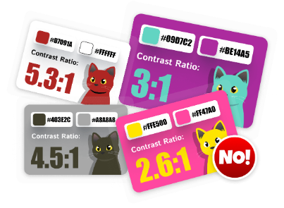
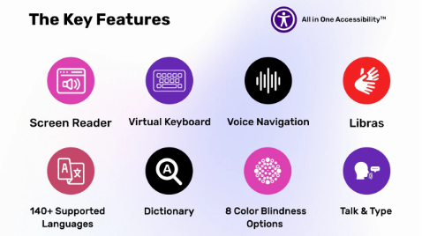

  - Real World Examples
Example of good UI and accessibility (Khan Academy)
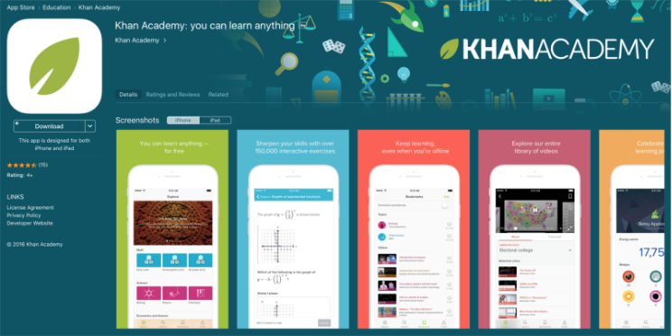
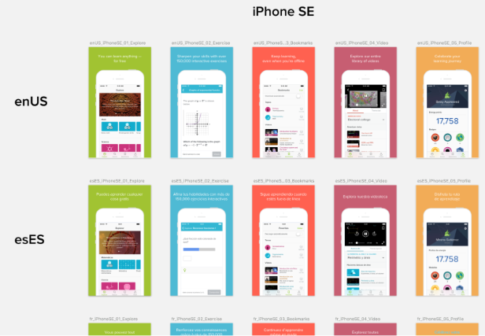
Supplies and accessibility settings section.
Users can hide visually/speaking dependent content

  - Examples of Bad UI and accessibility (Duolingo)
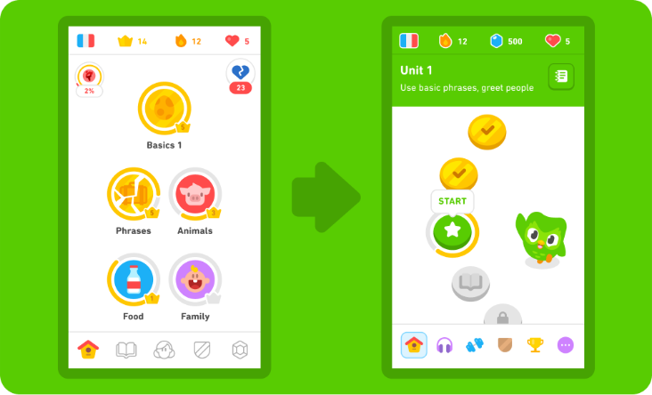
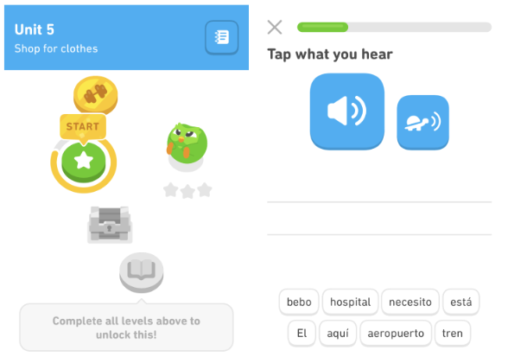
Certain types of exercises use controls that the screen reader can’t locate according to users
Given a 1 star for accessibility as there “seemed to be a lack of acknowledgement for different types of learners”
  - Accessibility standards:
When implementing the design of the interface is important to consider:
User interface design;
- High contrast color: for user with low vision
- Scalable text: This would be in response to responsive layouts.
- Clear visual hierarchy: Useful for screen reader and clear navigation for user with disability around the page
  - Assistive technology support:
- Screen reader compatibility with the use of HTML semantics
- Keyboard navigation: for user that cannot use a mouse
- Voice control interaction: Hands free interaction with user.
- AI audio description: Use of AI to read and provide description of videos or images to the user

User Personas and User Journey Mapping
Name – John Smith
Age - 53
Role - Tutor
Goals – Be able to view his timetable of classes, manage students/classes
Challenges – Digital Literacy is not very good
Devices used - Phone
Accessibility needs - Dyslexia Friendly Fonts
Quote – I want to be able to see my classes and manage them
Step | Action | Touchpoint | Thoughts/Feelings | Pain Points | Opportunities
1 | Logs in | Login Page | I hope I remember my password and username | No password/username reset option | Add forgot password/username link
2 | Clicks on timetable | Timetable | I hope it loads up quickly | Timetable doesn't load | Prompt user to reload the page if it hasn’t loaded after 10 seconds
3 | Mark students' attendance | Timetable attendance | Where do I mark them as not attending | Attendance buttons not clearly ladled | User cleaner icons and labels
4 | Manage classwork | Classwork page | I hope i can easily access my different classes | Classes not organised in a consistent manner | Organise classes in alphabetical order and give the user can edit button where they can group the and reorder them.

Name – Emma Villa
Age - 28
Role - Tutor
Goals – Report incidents, book equipment, manage classes manage students and give feedback to them and their parents/guardians
Challenges - English is not her first language
Devices used – Phone/Laptop/Computer
Accessibility needs – Translate Option
Quote –I just want to be able to manage my students and report incidents
Step | Action | Touchpoint | Thoughts/Feelings | Pain Points | Opportunities
1 | Login in | Login Page | Do I have the options to check remember me for password and username | No authentication of user login | Connect login page using an API to perform multi-factor authentication
2 | Report incidents | Report page loads | Can I just enter the name & other criteria of the incident, and it automatically generate a report at the end | Integration of other modules could lead to crashing of system | Perform load and integration testing
3 | Book Equipment | Book equipment requesting | I hope the equipment booked are not altered and I can also cancel the request | Lack of verification of user booking. Possible | Verify user booking integrate time modules into calendar to perform remainder on sessions
4 | Manage classes | Class activities | Can i view information regarding the classes & its relation to the students | SQL injection into database information on student | Integrate system testing of modules in relation to html semantics to provide meaningful insights to the tutor

Name – Owen King
Age - 18
Role - student
Goals – To use application effectively for learning due to poor class learning, manage reports on his classes, More interaction with tutor.
Challenges – Low vision, Poor accessibility to join online classes due to application only on desktop and laptop
Devices used – Phone But current operating system isn’t compatible with application
Accessibility needs – Provision of E-Books for learning
Quote - “The application is poor for my liking”
Step | Action | Touchpoint | Thoughts/Feelings | Pain Points | Opportunities
1 | Login on current OS | Login Page | I hope I can login on my phone it will make it much easier | Current phone will not work with site | Make application usable with multiple different OS and different quality devices
2 | Navigate the app | Home Page | I can't see clearly so I hope the app is accessible | The apps colour scheme is not suitable for people with bad vision | Give users accessibility settings and make sure the base app has a good clear colour scheme
3 | Wants o to join a class | Classes page | I hope I can join the class | Can only join classes on Desktop | Allow users to be able to join classes on their phones
4 | Interact with his tutor | Messaging page | I hope I can message my tutor to ask for advice/help | Messaging system is not clearly defined | Make the messaging system accessible
5 | See reports of his classes | Feedback page | I hope I can see how I'm doing | The report page is not easy to get to and understand | Give the report system a clearly defined button and make it much easier to understand

Name: Sam Sung
Age: 14
Role: Student
Goals: To use application for effective learning
Challenges: English is not his first language (Foreign Student)
Device used: Phone/Computer/Laptop/Tablet
Accessibility needs: Translation of current to user setting to meet user preferences
Quote: 由于英语不是我的母语，所以使用这个系统有点困难，但我还是希望这个应用程序能帮助我教英语 Translated （It is hard to navigate through the system since English is not my first language, but I would also prefer the application to teach English）

Accessibility Checklist
Accessibility: Give users a colour-blind mode
How it Supports the user: It allows users who are colourblind to still see the app in a suitable way so they can use it the same as anyone else
How it can be implemented: Will allow the user to choose the type of colour-blind mode they want to use
What happens if it's not included: People who are colour blind will not either be able to properly use our app or will have a bad experience.

Accessibility: Keyboard accessibility
How it Supports the user: Allows user to insert to transition from touchscreens to keyboard to tab trough the page
How it can be implemented: Addition of semantic pseudo classes such as hover, focus, focus-visible, focus within on the CSS which highlight the elements or portion of the page you are focusing on.
What happens if not included: it prevents user which prefer to use keyboard over touchscreen to navigate through your webpage

Accessibility: Screen Reader
How it Supports the user: It allows people who can’t see well or have difficulty reading to understand and use our app
How it can be implemented: Add descriptive alt attributes to all images
What happens if it's not included: Users who use screen readers will not be able to use our app.
Accessibility: Built in Magnifier
How it Supports the user: It allows user to enlarge elements of the page such as images, fonts and text
How it can be implemented: Could implement a shortcut tool for the page using JavaScript to provide the magnifier
What happens Text and images might be blurry to the user if not added

Accessibility: Video Translation/Subtitles
How it Supports the user: If users cannot hear then they will be able to turn on subtitles and see what the video is saying, and they will be able to click a button where the user can video transcript
How it can be implemented: convert spoken audio into written text, translating the text and synchronising it with the video footage
What happens if it's not included: People who are deaf or had difficulty hearing will not be able to fully use our app

Accessibility: Allow users to change colour of the page
How it Supports the user: It allows users who may have difficulty seeing on a certain colour change the colour so they can read it properly
How it can be implemented: Give the user an option to change the colour of the text and background
What happens if it's not included: Users who can’t read on certain colours will have difficulty using our apps

Accessibility: Addition of width and height to the images.
How it Supports the user: It prevents cumulative layout shift
How it can be implemented: The width and height of an image should be assigned the correct dimension to the on the IMG tag
What happens if it's not included: It can lead to accidental clicks of other elements such as buttons or overflow of images in their containers

Accessibility: Flash notifications
How it supports the user: Things like subscription to a newsletter from the webpage provide instant updates to user which can be added to an audio reader which can be useful to user with hearing impairments
How it can be implemented: Using a push notification service such as Firebase or Cloud messaging
What happens if it's not included: Users may stop using the app as they don’t know if there is any new content

Wireframes

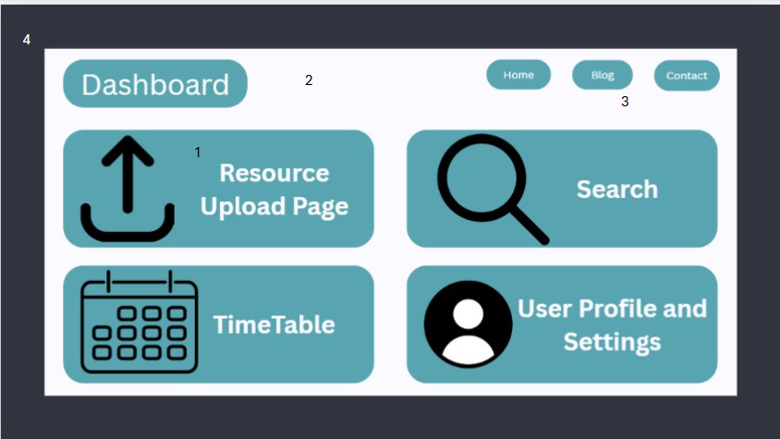
1 | We have 4 clear icons that stand out and allow the user to easily navigate the dashboard
2 | We have lots of white space to allow the elements to stand out so the user can see where we want them to go
3 | In the top right we have the common conventions such as Home Blog and Contact bar which helps the user feel familiar and allow for easy navigation
4 | We have chosen a colour scheme using cooler.io allowing the parts we want to stand out stand out.
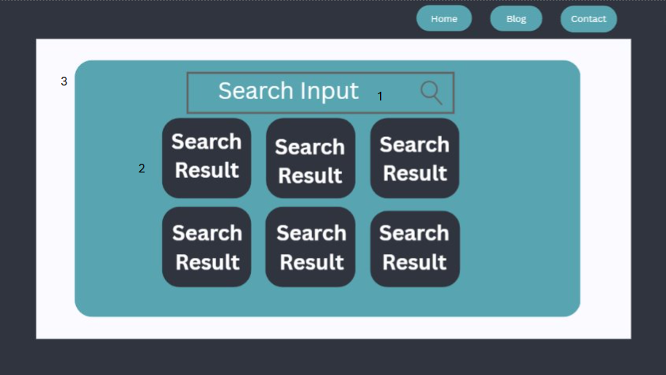
1 | We have a search bar which is the common convention for these types of pages allowing the page to become more recognisable and allowing the user to navigate it easier ​
2 | We will display our search results in boxes which when clicked on will direct the user to the relevant page. This allows us to condense a small amount of info into a block giving the user a basic understanding of what they are clicking on.
3 | We have very little on the page other than searching this allows the searching function to stand out and direct the user to it. This helps reduce confusion and increases ease of access
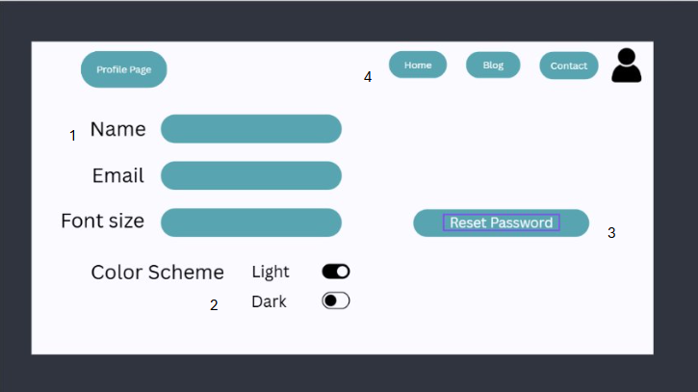
1 | We have used the same input bar for all the 3 inputs so that the users can tell they are connected to one another​
2 | We have given the user an option to turn on light mode or dark mode. This accessibility option will allow for a better user experience
3 | We have a reset password away from the user info so that the users can clearly see where they can reset their password
4 | In the top right we have an option where the user can click onto our other page allowing ease of access and a better user experience
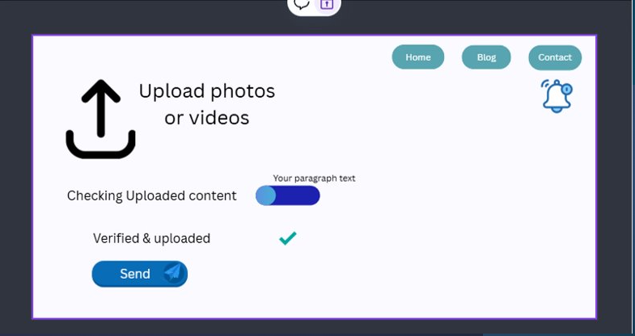
1 | We have added an icon which resembles that of an uploaded icon which makes it easy for the user to understand
2 | I have added a progress bar which helps to gives a clear indication that the uploaded file is in progress
3 | I provided a checkbox icon which the computer will tick if the file has no error in transit
4 | Provided a notification icon in any event of an error in uploading

Testing Strategy
  - Define the Purpose of testing
The purpose of testing constantly testing your project including your code and wireframe is to be able to find errors early. This is key to make sure you do not make any logical errors which could cause a bigger issue later in the project. Identifying these errors early on help the project run smoother and be more efficient leading to a cheaper and better result. Examples of problems you could find could be accessibility errors such as no WCAG compliance, logical errors such as user inputs leading to wrong paths or a calculation giving the incorrect result, testing the data flows correctly ensuring a safe and efficient transport of data which will help comply with the computer misuse act and the GDPR.
  - Outline testing types
In the testing of software applications testing are divided into 2 manual and automation testing. Manual testing is a type of testing which doesn’t involve any tools or automation to perform testing, int this case testers make testcases for codes to test the software and give final reports about the software. Developers use manual testing when they wish to perform:
- Exploratory testing: Discovering issues in new or unclear features by exploring them
- Usability testing: Checking if the UI is easy to use and look good
- Ad-Hoc testing: Doing quick, informal tests after updates or bug fixes
- Viability & GUI testing: Checking of the layout colours or how the site looks across different browsers.
  - Test Scenarios
Scenario | User uploads a Resource
Expected Outcome | The upload button is clearly visible once clicked it will prompt the user to choose a file from their device. Once they select their file it will upload and give an estimated time to upload and have a bar where it displays its progress. Once completed it will pop up on their device saying upload completed

Scenario | User reset password and email
Expected Outcome | The user gets given the options to reset their password and email. Ensure the user can clearly see their email and password being typed in the input field, ensure new password doesn’t match the current password provide another input field for the user to confirm the password they typed in. And for the email when the user wishes to change it ensures that the format of the email is correct and if so perform multi factor authentication on the email to conform the user credibility.

Scenario | User Searches for a resource
Expected Outcome | The user will type in the search bar. As the user types it will bring up the most relevant result constantly updating until the user stops typing. It must bring up the most relevant pieces of information.

  - Success Criteria
- Comply with all WCAG accessibility standards
- Users should be able to easily navigate the app (under 3 steps)
- Data flow is safe and efficient
- User should be able to complete tasks without confusion (under 3 steps)
- The colour scheme is easy on the eye (using coolors.io)
- Ensure users data is protected properly (Comply with GDPR)
  - Issue Reporting
Issue Evidence | Issue Explanation | Date of Issue
Photo/Video | Upload not working | 24/11/2025
Accessibility to internal data on device (Photo/Video Proof) | It failed to allow user to confirm access to device data from application | 24/11/2025
Contrast checker (Light & dark mode) | Implementation of JavaScript function in relation to internal style framework (Tailwind CSS) failed in provide toggle switch for user | 25/11/2025

Accessibility Review
  - Potential Issues
- There is no clear setting button which may make it harder for users who want to change accessibility features to be able to see them
- Lack responsive layout approach & design which would make it unsuitable for smaller designs and screens which can make it subjected to cumnulative layout shift which would be a problem to users on site.
  - New Version
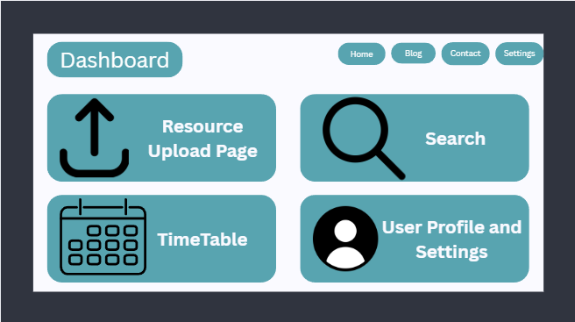

  - Potential Issues
- The space between the search input and first row of search results is small which could lead to users accidently clicking on the wrong bits
- Poor suggested search result arrangement in columns instead of rows.
  - New Version
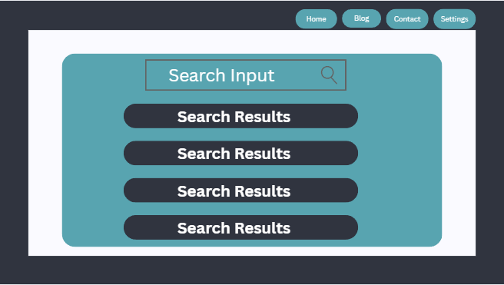Number 3
Potential issues
- Input filed for the font size is bad because user can enter any value.
New version

